7.46: a) 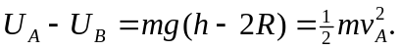 From previous considerations, the speed at the top must be at least 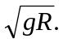 Thus,
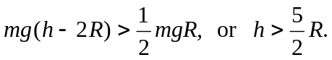
b) 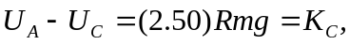 so
The radial acceleration is 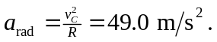 The tangential direction is down, the normal force at point C is horizontal, there is no friction, so the only downward force is gravity, and 